BAGLUNG MUNICIPALITY — WARD 10
Bhakunde Homestay & One-Day Tourism Route Strategy

1. Existing Situation & Key Evidence

1.1 Stakeholder baseline
A ward chairperson statement provided for this study reports 11 homestays identified in Bhakunde, of which 4 are currently operating in Ward 10.

1.2 Published evidence
Independent reporting broadly confirms Bhakunde's status as Baglung's leading homestay cluster, though the reported count of houses differs by source and by year:
- Khabarhub (20 July 2025) describes Bhakunde as home to Baglung's first homestay, established in 2068 BS (2011/12 AD), and reports steady visitor flow with the Barahatal lake as the main draw.
- A separate Khabarhub report (12 July 2025) states Bhakunde village has around 15 homestays, but notes that monsoon-damaged roads left them largely empty for several months of the year.
- Ratopati (4 March 2026) confirms Bhakunde as a Magar community settlement offering homestays, and names the Mulabari View Tower, Baraha Lake and Hira Lake as its principal linked attractions, with a rhododendron-season welcome tradition each Chaitra–Baishakh (mid-March to mid-May).
The gap between the stakeholder figure (4 operating, 11 identified) and the press figure (around 15) is real and should not be resolved by assumption. It is treated here as a data-quality issue to be closed by a field/GPS survey (see Phase 1, Section 9), not as a design input.

1.3 Tourism assets
Baraha Taal (lake and temple) • Mulabari / View Tower • Hira Lake • Magar culture and local food • Himalayan panorama • Tribal museum
- Key planning issue: accommodation alone is not the bottleneck. Accessibility, seasonality, and the connection between homestays and nearby activities strongly affect occupancy.
- Goal: create a one-day visitor circuit that converts day visitors into overnight guests.
- Approach: strengthen a strategic homestay cluster near existing activity nodes, rather than scattering new units across the ward.

2. Why Tourist Flow Can Increase in Ward 10
The following factors, drawn from current tourism evidence, explain Bhakunde's growing appeal and where the growth potential lies.
Factor | What the evidence shows
Mountain panorama | Views toward the Dhaulagiri and wider Annapurna Himalayan range, including the Dhaulagiri reflection on the Baraha Taal water; strong sunrise/sunset potential.
Baraha Taal | A scenic lake and temple that has been substantially upgraded — retaining walls, protective fencing and a railed footpath were added with roughly NPR 5 million in joint District/Provincial/Federal investment, and residents report steady year-round visitor flow, strongest in the monsoon when the lake is at its most scenic.
Mulabari / View Tower | A dedicated view tower built by the municipality in Ward 10 for panoramic sunrise, sunset and Himalayan viewing.
Magar culture | Bhakunde is a Magar community settlement; village life, traditional food, and community-based hospitality are recurrently cited by visitors as the distinguishing experience.
Rhododendron season | Mid-March to mid-May (Chaitra–Baishakh) brings a distinctive seasonal offer — homestay hosts traditionally welcome guests with rhododendron flowers picked from the surrounding forest.
Access | Bhakunde is reachable in roughly one hour on foot, or by vehicle, from Baglung Bazaar via Titiang; monsoon-season road damage is a documented and recurring constraint on arrivals.

3. Activity Mapping — What Visitors Can Do
- Baglung Bazaar — arrival, breakfast/lunch and supplies.
- Titiang approach — the main road-access and drop-off point into Bhakunde.
- Bhakunde — the homestay cluster base and village core.
- Bhairavsthan — a religious/cultural node within the circuit.
- Baraha Taal — lake, temple and lakeside walk.
- Hira Lake — nature spot and short hike.
- Mulabari / View Tower — sunrise and sunset viewpoint.
Suggested planning logic: arrival → activity → village and culture → overnight homestay → early-morning viewpoint → departure.

4. Proposed 1-Day / 1-Night Visitor Route
A route designed to make the homestay the overnight anchor of the visit, rather than a stop visitors pass through.
Time | Location | Activity
08:00 | Baglung Bazaar | Breakfast, arrival, local market
09:00 | Titiang → Baraha Taal | Walk/hike, lake and Baraha temple
11:00 | Bhakunde village | Village walk, landscape and photography
12:30 | Homestay | Local lunch and rest
14:30 | Magar cultural activity | Local food, farming, craft and cultural interaction
16:30 | Hira Lake / nearby trail | Short nature walk
18:00 | Homestay | Sunset, dinner and cultural programme
05:30 (next day) | Mulabari / View Tower | Sunrise and Himalayan panorama
07:30 | Homestay | Breakfast, departure

5. Strategic Location for a New / Upgraded Homestay Cluster

5.1 Preferred location characteristics
- Within or near the existing Bhakunde settlement and homestay cluster.
- Direct pedestrian connection to Baraha Taal and village activities.
- Short, safe walking connection toward Mulabari/View Tower.
- Clear Himalayan viewing orientation — the claimed multi-peak panorama should be verified on site.
- Vehicle drop-off and small parking area without disturbing the village core.
- Confirmed feasibility for water, sanitation, electricity and waste management.
- Sloped land with stable ground and minimal cut/fill.

5.2 Site-selection scorecard (indicative weighting)
Criterion | Weight
Accessibility | 25%
View potential | 20%
Proximity to attractions | 20%
Utilities feasibility | 15%
Terrain / safety | 10%
Community integration | 10%

5.3 Spatial strategy
Create a compact homestay cluster rather than isolated buildings: a shared arrival court, 4–6 guest units initially, a common dining/cultural space, a view deck and garden, and a service and waste zone set behind the guest areas. Expansion should occur in phases as occupancy demonstrates demand.

5.4 Site (Selected)
Applying the criteria and scorecard above, the site is the upper Bhakunde plot on the trail linking the village core to Mulabari / View Tower, directly above Baraha Taal. This location is retained as the preferred site for the homestay cluster on the following basis:
- Sits within the existing Bhakunde settlement and homestay cluster, keeping the community-integration benefit intact.
- Direct, short pedestrian access downhill to Baraha Taal and up to Mulabari / View Tower, satisfying the two proximity-linked criteria in the scorecard.
- Sloped, open ground with an unobstructed orientation toward the Himalayan view corridor described in Section 2.
- Vehicle drop-off achievable from the Titiang approach road without routing traffic through the village core.
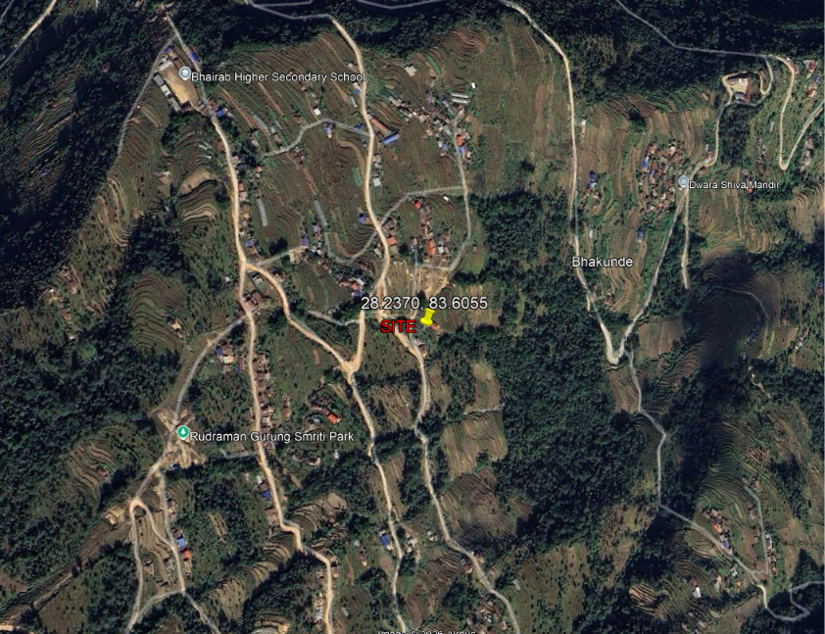
Figure 1:SITE(UPPER BHAKUNDE)

This Site is intended as the upper Bhakunde / trail-side zone, not the lake. It is approximately 0.8–1 km north/uphill of the Baraha Taal area.

6. Tentative Homestay Area Calculation
A concept-level estimate for a small, community-oriented homestay cluster. This should be refined after a site survey and against applicable Nepali building and tourism-facility standards.
Component | Basis | Area
Guest rooms | 6 rooms × 16 m² | 96 m²
Attached toilets | 6 × 4 m² | 24 m²
Common dining / kitchen | 1 × 35 m² | 35 m²
Living / reception | 1 × 20 m² | 20 m²
Cultural / multipurpose space | 1 × 25 m² | 25 m²
Circulation / wall allowance | ~20% | 40 m²
Service / storage | 1 × 12 m² | 12 m²
TOTAL BUILT-UP |  | ≈ 252 m²

Suggested land parcel: approximately 700–1,000 m² for a low-rise, one- to two-storey cluster with court, garden, parking/drop-off and room for future expansion.

7. Architectural Concept for the Homestay

7.1 Schematic block plan
The layout below translates the area calculation into a conceptual block plan: a guest wing of six 20 m² room-and-toilet units behind a shared view verandah, a circulation spine, and a common core of dining/kitchen, cultural hall and reception, with service and arrival areas set behind. Room adjacencies and proportions are indicative — exact dimensions and structural layout should be developed by an architect after the site survey.
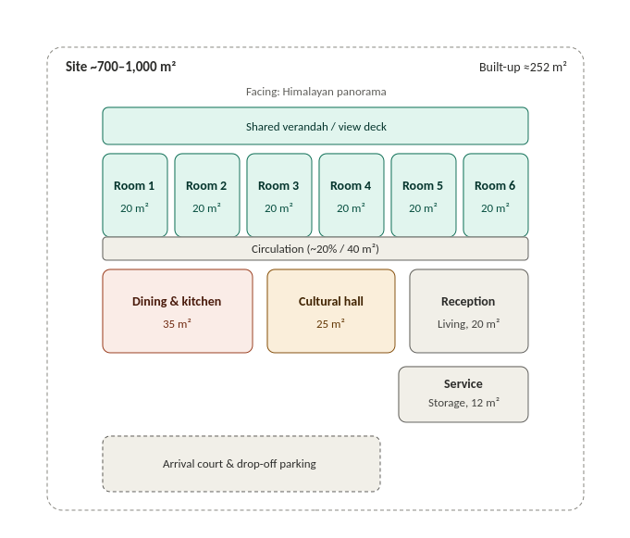
This single-line concept expands into three design drivers:
Driver | Design response
Form | Low-rise, pitched-roof form that follows the terrain; avoid excessive cut-and-fill.
View | Guest rooms and verandah oriented toward the strongest mountain/view corridor.
Climate | Deep eaves, cross-ventilation, a shaded verandah, and rainwater harvesting.

8. What Should Be Inside the Homestay?
Priorities: local experience, comfort, hygiene and small-scale visitor services.
- Guest bedroom: bed, side table, luggage bench, wardrobe/peg rail
- Attached toilet: WC, shower, basin, hot water
- Verandah/balcony: seating facing the landscape
- Common dining: 6–12 seat flexible table arrangement
- Local kitchen: traditional cooking plus a modern hygiene zone
- Living/reception: check-in, information, charging
- Cultural corner: local textiles, tools, photographs, crafts
- Small library / tourism information shelf
- First-aid and emergency contact board
- Wi-Fi / charging point where feasible
- Outdoor seating and a fire/cultural gathering space
- Waste segregation and a compost/organic-waste area
- Water storage and rainwater harvesting
- Local food display / farm-to-table garden

9. Recommended Planning Actions
A phased approach avoids overbuilding and links accommodation growth to actual tourist demand.

Phase 1 — Access & mapping
GPS-map the 4 currently operating homestays and verify all 11 reported units; map roads, trails, Baraha Taal, Hira Lake, the View Tower, cultural nodes and viewpoints.

Phase 2 — Visitor circuit
Install signage, route markers, rest points, waste bins and toilets; package Baraha Taal–Bhakunde–Mulabari/View Tower as a single one-night circuit.

Phase 3 — Homestay upgrade
Upgrade existing houses first rooms, toilets, dining, safety, local-food presentation and cultural programming — before adding new beds.

Phase 4 — New capacity
Add a new 4–6 room cluster only once occupancy, visitor numbers and length of stay show a genuine capacity gap.

